# Software User’s Manual

## Installation Guide

### Setting up environment at server side

The following software must be installed into the server machine:

#### Hardware requirements

Personal computers for developing with the minimum configuration:

* Processor: minimum Core 2 Duo 2.0 GHz.
* Memory: minimum 2GB RAM
* Available Disk Space: minimum 30GB hard disk
* Internet: minimum speed 10Mbps

#### Software requirements

* Web Server: Apache Tomcat 7.0.47 with JRE 7.
* OS: Microsoft Windows Server 2008 R2 Enterprise
* SQL Server 2008 R2: used to create and manage the database for web application.

### Deployment at server side

#### Setup environment variable

* Please go following path: Click **Properties** of **Computer**, then click **Advanced System Setting,** in “**Advanced”** tab select **Environment variables.**

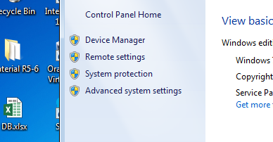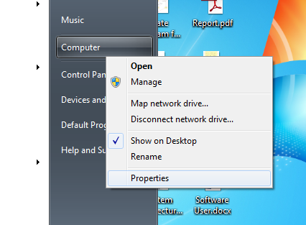

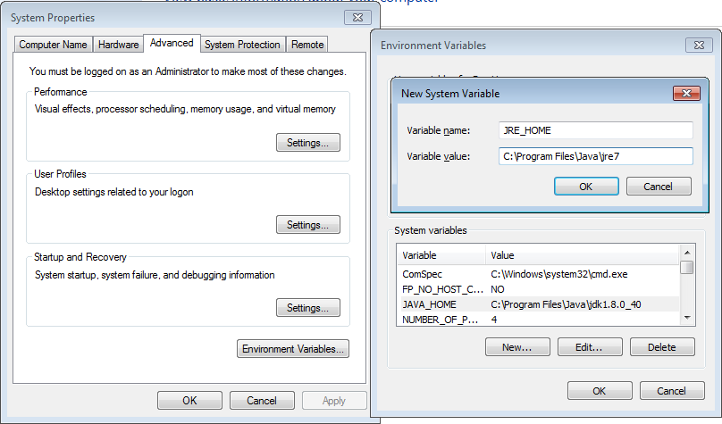

* Add variable **JRE_HOME**: Directory path of Java Runtime Environment.

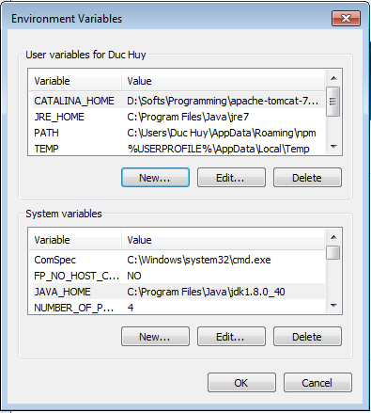

#### Prepare deployment package

#### Configure Server before deploy

* Open Microsoft SQL Server Management Studio and connect to server.

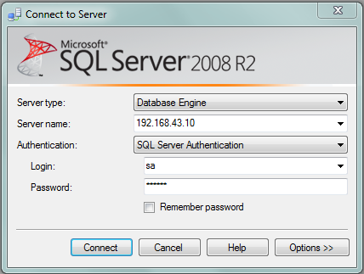

* Open and execute the FTS_DB.SQL file.

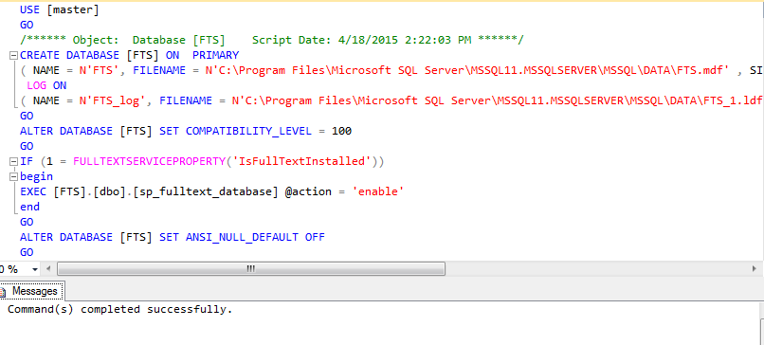

* Replace 1 and 2 with Microsoft SQL Server local installed path [local_path]/MSSQL\DATA. Then run script file by click Execute.

#### Deploy web application on server

* Please copy the deployment package **FTS.war** to a folder **webapps** in the directory of Tomcat server. Ex: C:\apache-tomcat-7.0.47\webapps

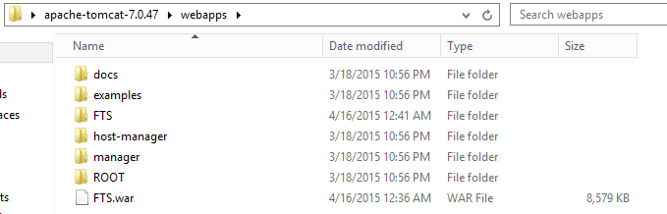

* Navigate to folder **bin** in the directory of Tomcat server. Then click startup.bat file to start the server and wait for server startup.

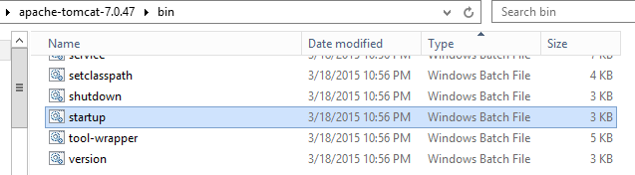

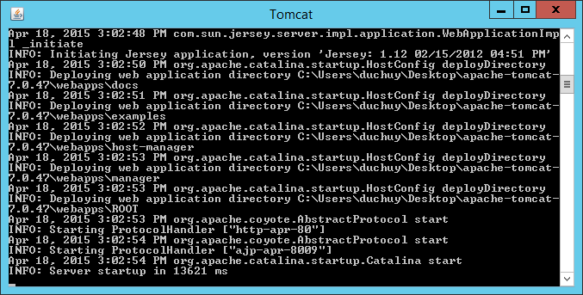

### Setting up the environment at client side

#### Setting up for computer

* The client devices need to have one of the following browsers to access the website: Firefox (v30 or above), Chromes (v14 or above) browser, enable JavaScript.

#### Setting up for Android device

* Change setting to install unknown source **apk**. Go to **Setting/Security**, tick check box **Unknown sources**.

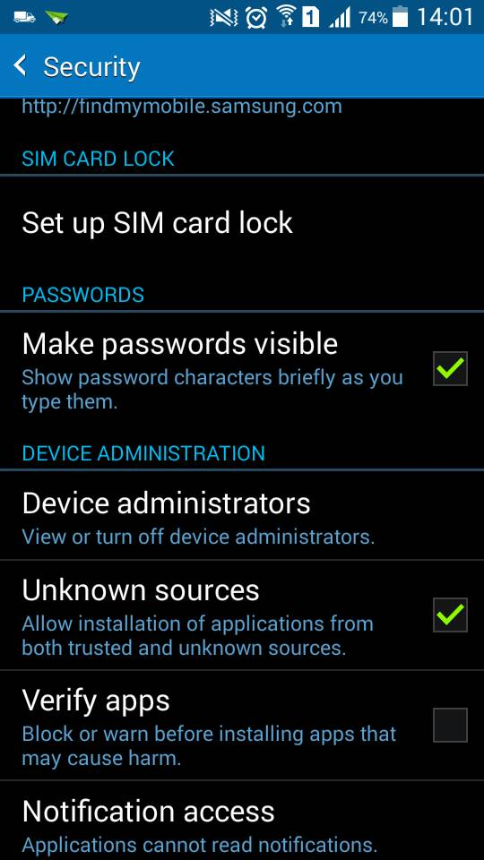

* Copy installation source into device external memory: **FTS Owner.apk or FTS Driver.apk**

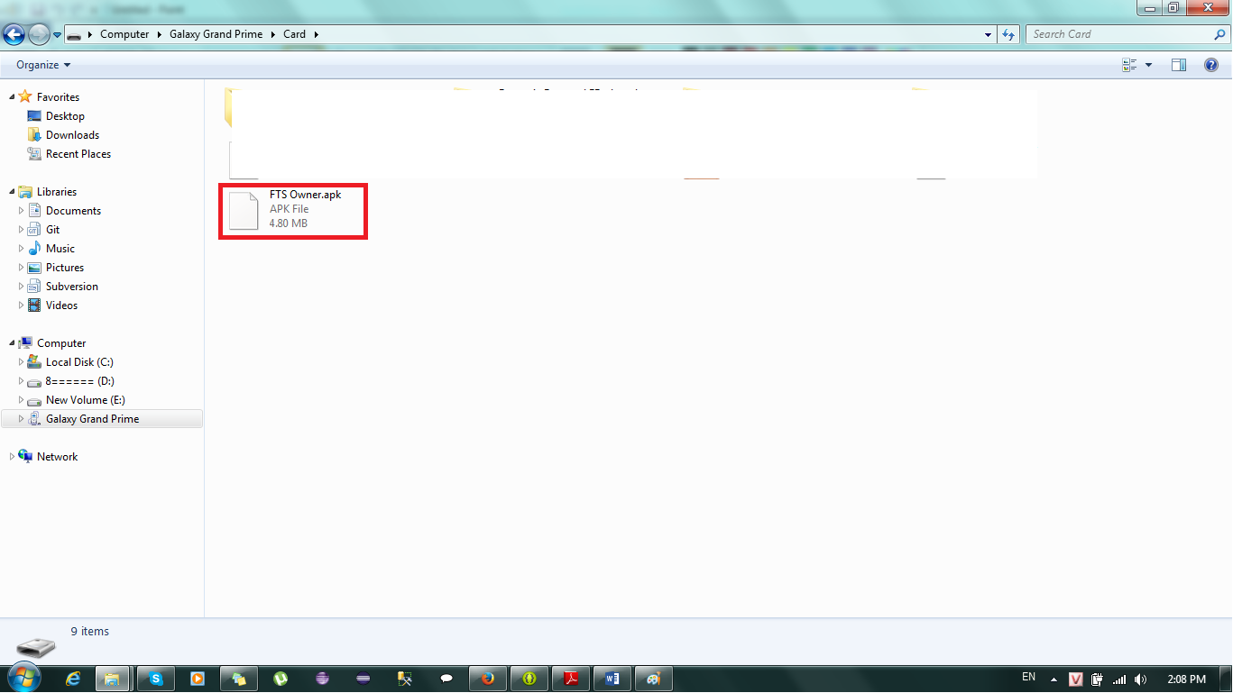

* Open Android file explorer, navigate to external memory directory. Click on file to install.

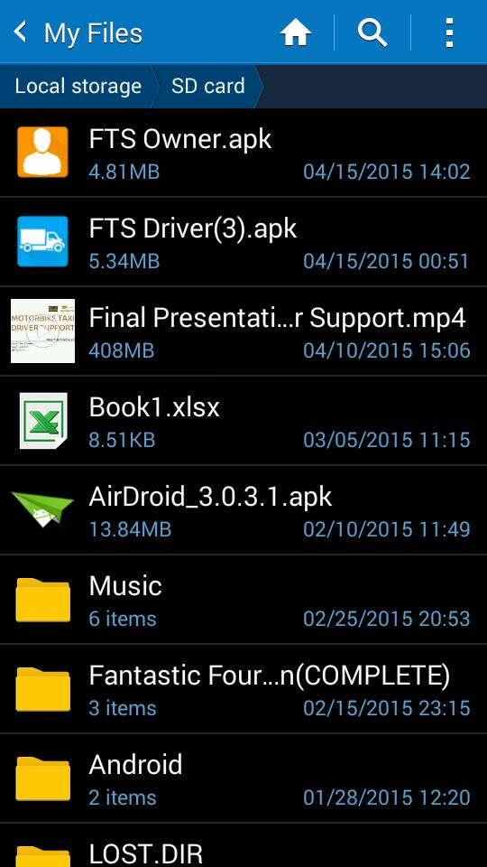

* Click Install

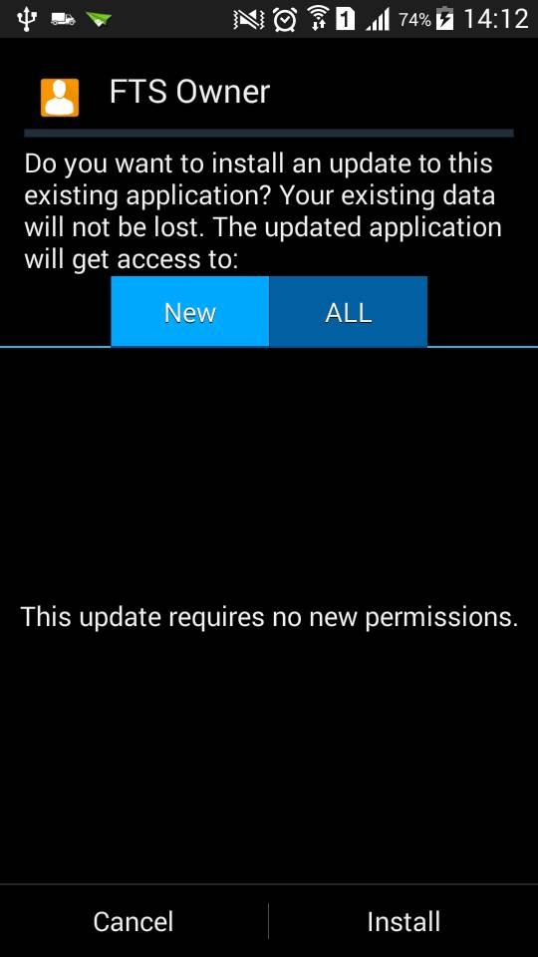

* Install success

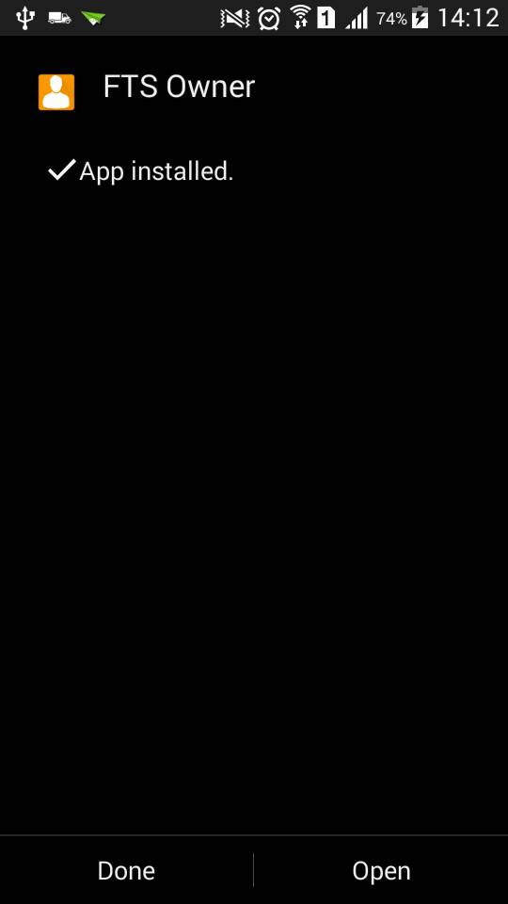

## User Guide

### Goods Owner Guide

#### Web Application

#### Android Application

##### Login

##### Create Goods

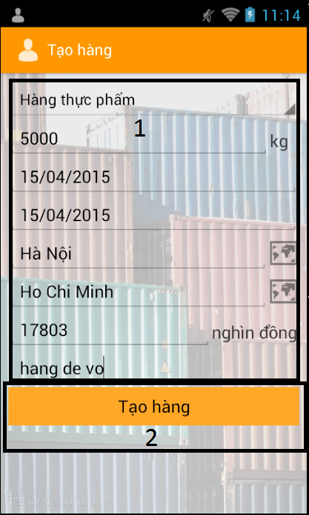

|  |  |
| --- | --- |
| Step | Description |
| 1 | Fill in fields:  “Loại hàng”: category.  “Khối lượng”: weight  “Ngày có thể nhận hàng”: possible pickup date  “Ngày có thể giao hàng”: possible delivery date  “Địa chỉ nhận hàng”: pickup address  “Địa chỉ giao hàng”: delivery address  “Giá tiền”: price  “Ghi chú”: note |
| 2 | Click “Tạo hàng” button |

##### View Suggestion Route

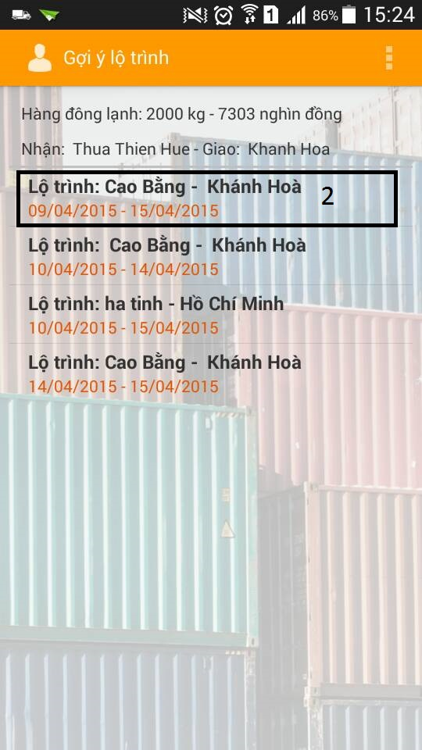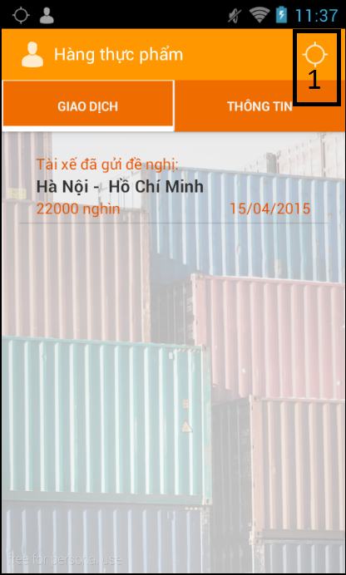

|  |  |
| --- | --- |
| Step | Description |
| 1 | Click “Gợi ý lộ trình” button |
| 2 | Thông tin lộ trình |

##### Send deal

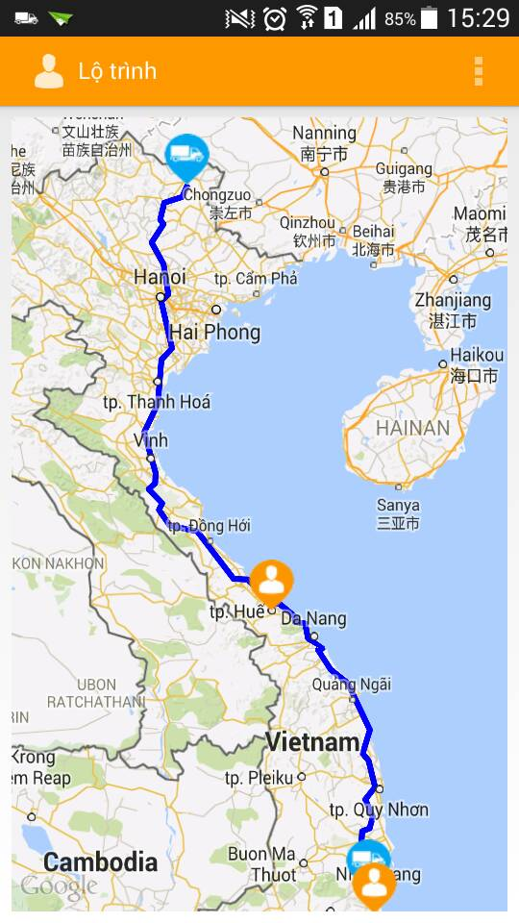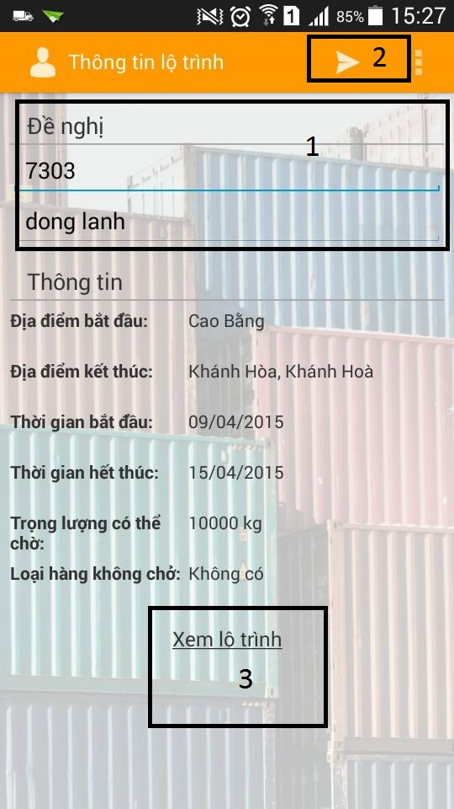

|  |  |
| --- | --- |
| Step | Description |
| 1 | Fill in field:  “Giá tiền”: price  “Ghi chú”: note |
| 2 | Click “Gửi đề nghị” button |
| 3 | Click “Xem lộ trình” link |

##### Confirm Deal

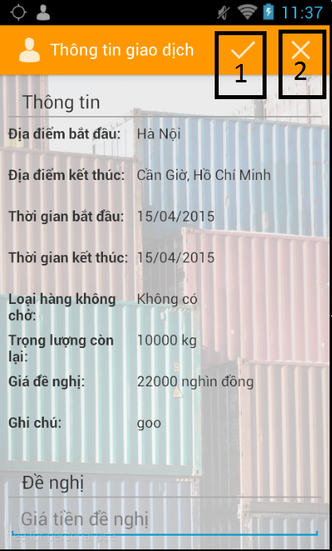

|  |  |
| --- | --- |
| Step | Description |
| 1 | Click “Đồng ý” button |
| 2 | Click “Từ chối” button |

##### Cancel Deal

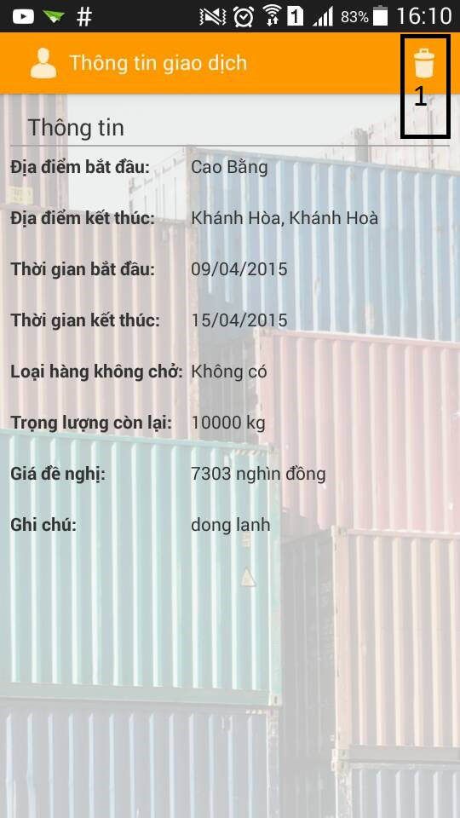

|  |  |
| --- | --- |
| Step | Description |
| 1 | Click “Hủy” button |

##### Counter deal

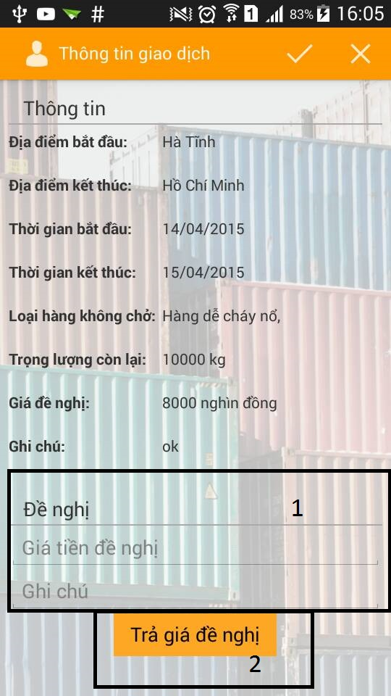

|  |  |
| --- | --- |
| Step | Description |
| 1 | Fill in field:  “Giá tiền đề nghị”: price  “Ghi chú”: note |
| 2 | Click “Trả giá đề nghị” button |

##### Report Order

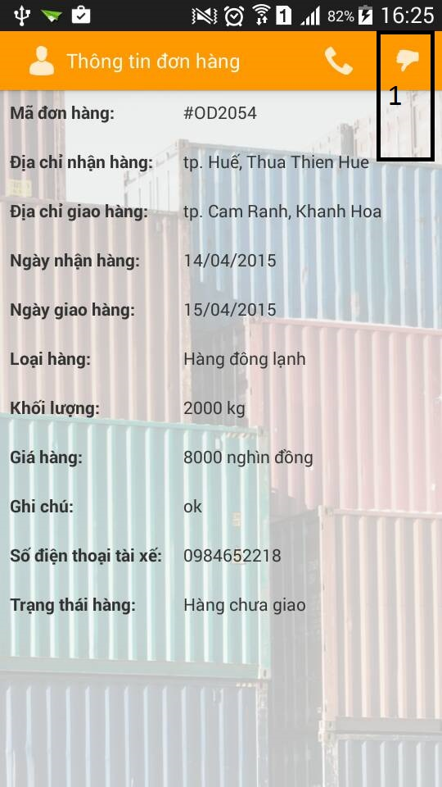

|  |  |
| --- | --- |
| Step | Description |
| 1 | Click “Phản hồi đơn hàng” button |

### Truck Driver Guide

# Appendix